POST FIRST MOCK INTERVIEW and QC STUDY GUIDE:

1. The Exception Hierarchy

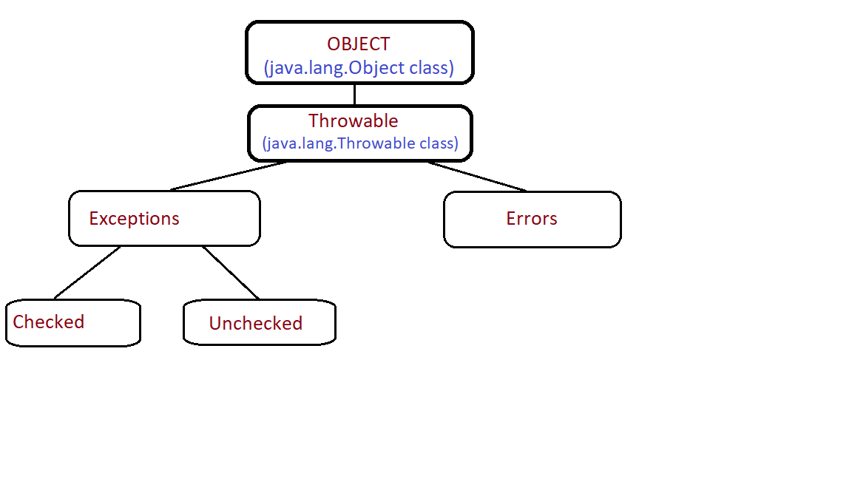

Errors should not be handled. They are big problems that completely break the program.

Exceptions come in two varieties. Checked exceptions occur at compile time, meaning that they are thrown when you click “run” to try to start a program. Unchecked exceptions happen after you click “run”, while the program is actually running.

For example: If you try to run your program and it can’t find a file, the FileNotFoundException will get thrown at compilation, right away. But if the program has a ‘bug’, like an ArithmeticException, you won’t know until the program runs into the issue.

Examples of checked exceptions (java.lang.Exception):
- ClassNotFoundException
- FileNotFoundException
- SQLException

Examples of unchecked exceptions (java.lang.RuntimeException):
- ArrayOutOfBoundsException
- NullPointerException
- ArithmeticException

How do you handle exceptions?

- Try/Catch Block

try... {
...doing some code
}
catch (thisException e) {
...if it breaks something
}

- Throw (customizable, e.g. users under 18 can’t create account, or a password isn’t secure enough)

if (age < 18) {
throw new ageRestrictionException (“You have to be 18.”)
} else {
print(“you’re old. come on in.”)
}

- Throws (declared along with the method)

checkPassword () throws someException {

}

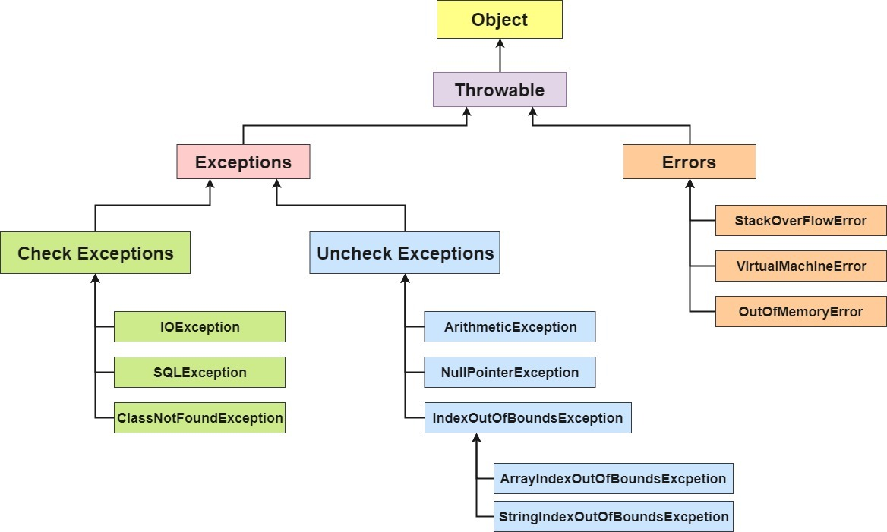
2. The Collections Hierarchy

note: the Collections Framework is a big group of different types of collections. the Collection Class is used to sort those types (Collections.sort(list or arraylist or set or whatever)

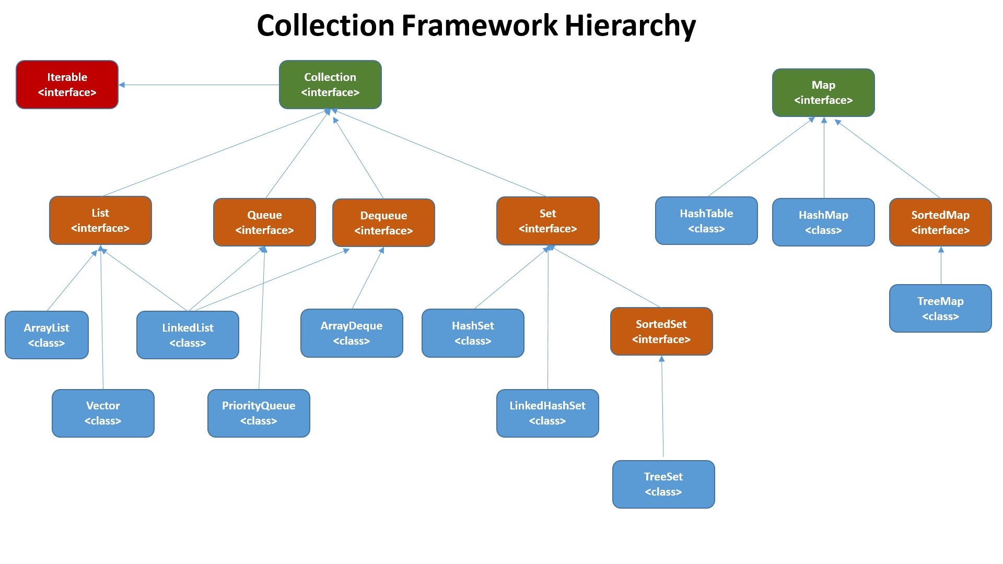
lists:
- ArrayList, Vector, LinkedList

3. Random Things to Know

Design Patterns:

- Singleton: Using a private constructor, make it so that only one instance of a class can exist. Used to control access. Example: a car object, but there is only one, so it’s color can’t be set to red and green, because there is only one car.
- Factory: Use an interface, but let the subclasses decide exactly what type of object to create. Example:

Mavin Life Cycle:

- validate – validate that the project is correct and all the required info is available
- compile – compile the project’s source code
- test – test the compiled source code using a testing framework
- package – take that compiled code and stick it in a distributable format, like JAR
- verify – run any checks on tests to make sure it is working as intended
- install – install the package into the local repo, for use as a dependency in other local projects
- deploy – done in the build environment, copies the final package to the remote repo for sharing with other devs and projects

Bits in each Primitive Type:
- boolean = 1 bit
- byte = 8 bits
- char = 16 bits
- short = 16 bits
- int = 32 bits
- long = 64 bits
- float = 32 bits
- double = 64 bits

Scope vs Encapsulation:

The scope of a variable might be local or global. Keeping a variable local could be one way of practicing encapsulation.

Java is a strong, statically typed language:

Unlike in JS, variables have a set type (int, short, long).

Common thread problems:

- synchronization
  - threads using the same variable, can’t have two copies
- deadlock
  - like two people trying to fit through a doorway at once;
- producer-consumer
  - ie trying to delete a resource that doesn’t exist yet

Variables are always called fields:

Because they all belong to classes, so calling them ‘fields’ is a way to emphasize that everything is a class in java
https://stackoverflow.com/questions/10115588/what-is-the-difference-between-field-variable-attribute-and-property-in-java

